

Subject: Introduction to problem solving and programming
Project Title: Data Visualization for Multi-branch hotel
using Python and MySQL
Submitted by:
Name: Vanshika Verma
Registration number: 25BCY10171
Branch: Computer Science (Cyber security and digital forensic)
Submitted to: Dr. A.V.R Mayuri

CONTENTS

1. Introduction to Python
2. MySQL Database System
3. Classification of SQL Statements
4. Front End & Back End
5.Minimum Hardware & Software requirements
6. User Working Analysis

7. ER Diagram

8. MySQL commands

9. Python Coding

1. Introduction to Python

What is Python?
Python is a popular programming language. It was created by Guido van Rossum, and released in 1991.
It is used for:
● web development (server-side),
● software development,
● mathematics,
● system scripting.

What can Python do?
- Python can be used on a server to create web applications.
- Python can be used alongside software to create workflows.
- Python can connect to database systems.
- It can also read and modify files.
- Python can be used to handle big data and perform complex mathematics.
- It can be used for rapid prototyping, and production-ready software development.

Why Python?
- Python works on different platforms (Windows, Mac, Linux, Raspberry Pi, etc).
- Python has a simple syntax similar to the English language.
- Python has syntax that allows developers to write programs with fewer lines than some other programming languages.
- Python runs on an interpreter system, meaning that code can be executed as soon as it is written. This means that prototyping can be very quick.
- Python can be treated in a procedural way, an object-oriented way or a functional way.

Good to know
- The most recent major version of Python is Python 3,which we shall be using in this tutorial. However, Python 2, although not being updated with anything other than security updates, is still quite popular.
- In this tutorial Python will be written in a text editor. It is possible to write Python in an Integrated Development Environment, such as Thonny, Pycharm, Netbeans or Eclipse which are particularly useful when managing larger collections of Python files.
Python Syntax compared to other programming languages
● Python was designed for readability and has some similarities to the English language with influence from mathematics.
● Python uses new lines to complete a command, as opposed to other programming languages which often use semicolons or parentheses.
● Python relies on indentation, using whitespace, to define scope, such as the scope of loops, functions and curly brackets languages often use curly brackets for this purpose.

2. MySQL-Database-System
MySQL is freely available open source Relational Database management System (RDBMS) that uses Structured Query Language (SQL). It is downloadable from site www.mysql.org In a MySQL database, information is stored in tables. A single MySQL database can contain many tables at once and store thousands of individual records. MySQL provides you with a rich set of features that that support a secure environment for storing, maintaining, and accessing data. MySQL is a fast, reliable, scalable alternative to many of the commercial RDBMS available.
My SQL database system refers to the combination of a MySQL server instance and a MySQL database. MySQL operates using client/server architecture in which the server runs on the machine containing the database and clients connect to the server over a network. MySQL is a multi-user database system, meaning several users can access the database simultaneously.
The sever (MySQL server) listens for client requests coming in over the network and accesses database contents according to those requests and provides that to the clients.
Clients are programs that connect to the database server and issue queries in a pre-specified format. MySQL is compatible with the standards-based SQL (Structured Query Language). The client program may contact the server programmatically (meaning a program call the server during execution) or manually.

3. Classification of SQL Statements
SQL provides many different types of commands used for different purposes. SQL commands can be divided into following categories:
- Data Definition Language (DDL) Commands:- Commands that allows you to perform tasks related to data definition. Ex: -
  - creating, altering and dropping
  - granting and revoking privileges and roles
  - maintenance commands.

- Data Definition Language (DDL) Commands:- Commands that allows you to perform tasks related to data definition. Ex:-
  - creating, altering and dropping
  - granting and revoking privileges and roles
  - maintenance commands

- DataManipulation Language (DML) Commands:- Commands that allows you to perform tasks related to data manipulation. Ex:-retrieval, insertion, deletion modification of data stored in database

- Transaction Control Language (TCL) Commands:- Commands that allows you to manage and control the transaction(a transaction is one complete unit of work involving many steps). Ex:-
- making changes to database, permanent
- undoing changes to database, permanent
- creating savepoints
- setting properties for current transactions.
MySQL was created and is supported by MySQL LAB, a company based in Sweden. This company is now a subsidiary of Sun Microsystems, which holds the copyright to most of the codebase. On April 20th, 2009 Oracle database, announce a deal to acquire Sun Microsystems. The chief inventor of MySQL was Michael Widenius (a.k.a. Monty). MySQL has been named after Monty’s daughter My. The logo of MySQL, the dolphine, is named as “Sakila”.
4. Front End & Back End

FRONT END
The project uses python as its FRONT END, that is it is the part where user interact. The front end basically includes input facilities through which the user interact. Apart from the user interaction, the front end also contains database objects that form a layer between the user and

BACK END
MySQL is used as a BACK END. It handles all database accesses through one or more servers. A Server is a special computer that is responsible for processing requests send to it. It processes all the data and query passed to it and sends result back to the front end where it is displayed to the user.

5. HARDWARE AND SOFTWARESPECIFICATION
Minimum Hardware Specification of the machine to be used:
⮚P-1 Processor
⮚32MB RAM
⮚14 inchcolor monitor
⮚2.1GB HDD
⮚233 MHZ CPU Clock Speed
Minimum Software Specification of the machine to be used (tools & platforms used)
⮚Python 3.6 and above
Project Category:-
This project uses GUI provided by Python and MySQL which is a RDBMS.

6. USER WORKING ANALYSIS
IN THE BUSTLING HOSPITALITY INDUSTRY, MANAGING A MULTIBRANCH HOTEL INVOLVES A COMPLEX NETWORK OF OPERATIONS ACROSS VARIOUS LOCATIONS. EACH BRANCH OPERATES AS A SMALLER UNIT IN A LARGER HOTEL NETWORK REQUIRING PLANNING, PROCESSES AND EFFICIENT COMMUNICATION. THIS ANALYSIS EXPLAIN HOW CUSTOMERS, AND STAFF WORK TOGETHER IN A MULTIBRANCH HOTEL. THE INFORMATION ABOUT EACH CUSTOMER IS STORED IN CUSTOMER TABLE IN THE FORM OF CUSTOMER ID, NAME, EMAIL, ADDRESS AND AGE. STAFF TABLE KEEPS THE RECORD OF HOTEL STAFF. IT STORES THE STAFF INFORMATION IN THE FORM OF STAFF ID , CONTACT NO., NAME, POST AND BRANCH ID. HOTEL BOOKING IS MANAGED BY TRACKING THE DETAILS OF THE ROOMS AVAILABLE FOR BOOKING AT WHICH BRANCH. IT STORES IN THE FORM ROOM NO., PRICE AND BRANCH. BOOKING TABLE INVOLVES THE RECORD OF THE BOOKINGS TAKING PLACE AT EACH BRANCH. IT INVOLVES THE CUSTOMER ID, ROOM NO., DAYS, TRANSACTION ID, RATING. CUSTOMER REGISTER WITH THEIR DETAILS EITHER ONLINE THROUGH THE OFFICIAL WEBSITE OR THROUGH ANY HOTEL BOOKING APP. THEY SELECT THE BRANCH , ROOM TYPE, AND TIME TO CHECK IN & OUT. STAFF MEMBERS HELP THE CUSTOMER TO FIND THE BEST ROOM FOR THEM. THE HOTEL KEEPS AN ORGANISED LIST oF AVAILABLE ROOM.THIS USER WORKING ANALYSIS PROVIDES A SIMPLE FRAMEWORK FOR MANAGING CUSTOMER INTERACTIONS AND STAFF ROLLS WITHIN THE DIFFERENT BRANCHES. THIS ORGANISED STRUCTURES IMPROVES EFFICIENCY AND ENSURES A SMOOTH EXPERIENCE FOR EVERYONE INVOLVED
7. ER DIAGRAM

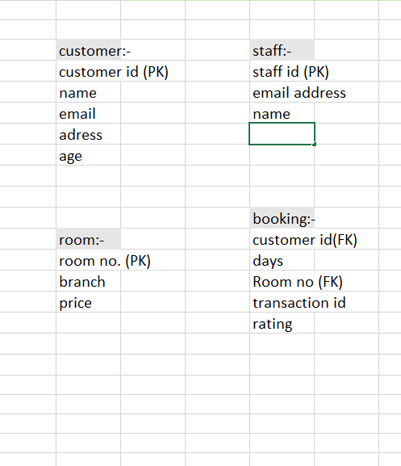

8. MY-SQL Commands

mysql> create database dh;
Query OK, 1 row affected (0.01 sec)

mysql> use dh;
Database changed
mysql> create table customer
-> (customeridinteger(9) primary key,
-> name varchar(15),
->emailidvarchar(12),
-> address varchar(22),
-> age integer(2))
-> ;
Query OK, 0 rows affected, 2 warnings (0.04 sec)

mysql> insert into customer
->values(1001,'Rahul','rahul@gmail.com','Malviya Nagar Delhi',24),
-> (1002,'ali','alikhan@gmail.com','saket nagar bhopal',21),
-> (1003,'chayan','chayanjariwala@gmail.com','imambada indore',31),
-> (1004,'avani','avanishukla@gmail.com','kurla nagar indore',36),
-> (1005,'ibrahim','ibrahim@gmail.com','lajpal nagar delhi',28),
->(1006,'palak','palaksingh@gmail.com','chandni chowk delhi',41),
->(1007,'viraj','virajsingh@gmail.com','aerocity bhopal',32),
-> (1008,'aryaman','aryamansingh@gmail.com','bandra mumbai',33);

-) select * from cutomer

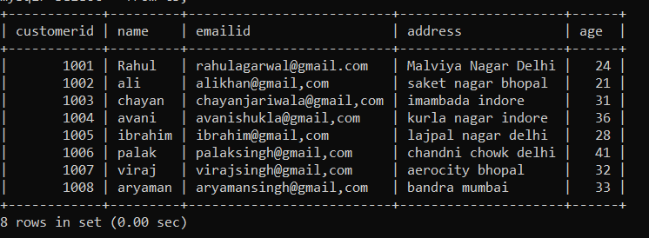

mysql> create table room
-> (roomnumberinteger(3),
-> price integer(5),
-> branch varchar(19))
->
-> ;
Query OK, 0 rows affected, 2 warnings (0.03 sec)
mysql> insert into room
-> values(101,3000,'bhopal'),
-> (102,6000,'mumbai'),
-> (103,5000,'bhopal'),
-> (104,7300,'bhopal'),
-> (105,3300,'bhopal'),
-> (106,4500,'bhopal'),
-> (107,400,'bhopal')
-> ;
Query OK, 7 rows affected (0.01 sec)
Records: 7 Duplicates: 0 Warnings: 0

mysql> select * from room;

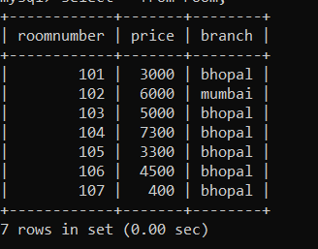

mysql> create table booking
-> (customeridinteger(9),
->roomnumberinteger(3),
-> daysinteger(2),
->transactionidinteger(9),
-> ratinginteger(4),
-> foreign key(customerid) references customer(customerid));
Query OK, 0 rows affected, 5 warnings (0.04 sec)

mysql> insert into booking
->values(1001,12,5,24354,4),
-> (1002,17,8,83094,8),
-> (1003,2,5,29856,9),
-> (1004,5,1,84326,5),
-> (1005,9,4,65454,7),
-> (1006,6,8,87098,4),
-> (1007,16,11,87654,6),
-> (1008,11,10,10293,5);

mysql> select * from booking;

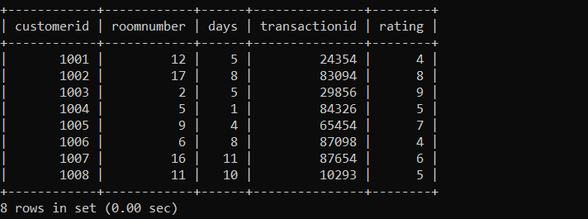

mysql> create table staff
-> (staffidinteger(9) primary key,
-> email varcharI(20),
-> post varchar(20),
-> name varchar(20));

mysql> insert into staff
->values(1654,'nandini@gmail.com','nandini sharma'),
-> (2934,'adil@gmail.com','adil ansari'),
-> (3948,'akshat@gmail.com','akshat kumar'),
-> (2039,'ajay@gmail.com','ajay'),
-> (5465,'anees@gmail.com','anees khan');
Query OK, 5 rows affected (0.01 sec)
Records: 5 Duplicates: 0 Warnings: 0

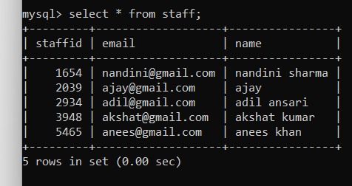

Data Analytical Display
Graph on table customer
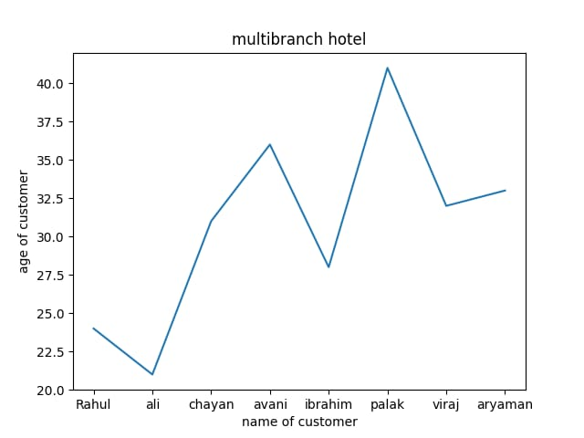

import mysql.connector
import numpy as np
import matplotlib.pyplot as plt

mydb=mysql.connector.connect(host="localhost",
user="root",
password="vit_25",
database="dh")

mycursor=mydb.cursor()

mycursor.execute("select name,age from customer")

result=mycursor.fetchall
name=[]
age=[]

for i in mycursor:
name.append(i[0])
age.append(i[1])

print("name of customer=",name)
print("age of customer=",age)

plt.plot(name,age)
plt.xlabel("name of customer")
plt.ylabel("age of customer")
plt.title("multibranch hotel")
plt.show()

Graph on table room

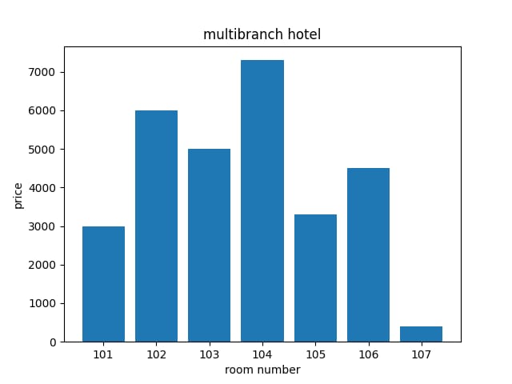

import mysql.connector
import numpy as np
import matplotlib.pyplot as plt

mydb=mysql.connector.connect(host="localhost",
user="root",
password="vit_25",
database="dh")

mycursor=mydb.cursor()

mycursor.execute("select roomno.,price from customer")

result=mycursor.fetchall
roomno.=[]
price=[]

for i in mycursor:
roomno..append(i[0])
price.append(i[1])

print("room number=",roomno.)
print("price of room=",price)

plt.bar(roomno.,price)
plt.xlabel("room number")
plt.ylabel("price")
plt.title("multibranch hotel")
plt.show()

graph on booking

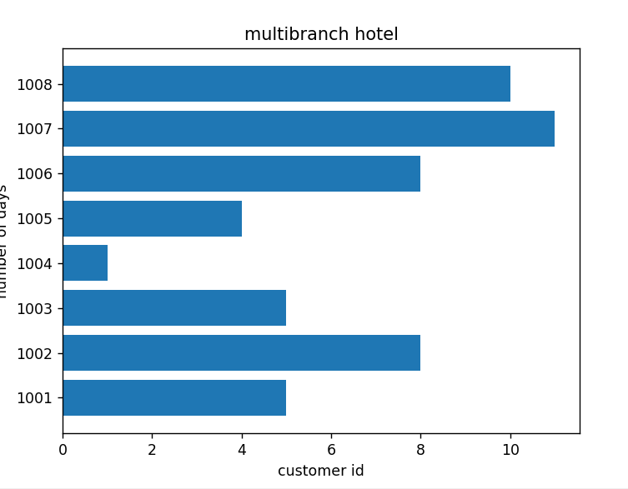

import mysql.connector
import numpy as np
import matplotlib.pyplot as plt

mydb=mysql.connector.connect(host="localhost",
user="root",
password="vit_25"
database="dh")

mycursor=mydb.cursor()

mycursor.execute("select customerid,price from booking")

result=mycursor.fetchall
customerid=[]
days=[]

for i in mycursor:
customerid.append(i[0])
days.append(i[1])

print("customerid=",customerid)
print("number of days=",days)

plt.barh(customerid,days)
plt.xlabel("customerid")
plt.ylabel("number of days")
plt.title("multibranch hotel")
plt.show()

BIBLIOGRAPHY

- Sumita Arora – Informatics Practices Class XII.
- www.geeksforgeeks.org
- www.youtube.com
- www.stackoverflow.com

